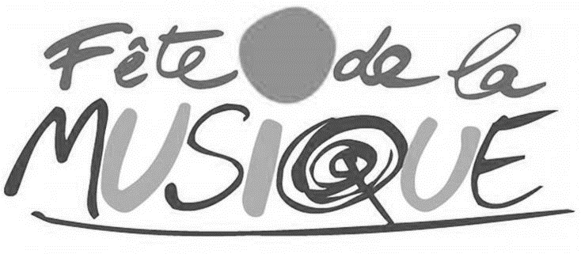

Artists Application Form
6 June 2020 - Fête de la musique - Newtown

All artist selected will be paid the same standard fee of R5000.
For this second wave, only the first 100 applications will be considered. So don’t waste time! Applications to be sent electronically by 10 April 2020
to fetedelamusiquejoburg@gmail.com

Name of the band/artist:

Genre:

Full name of all band members:

Contact
Name:
Tel:
Email:

Short biography (between 5 and 10 lines)

Links | Website:
 | Facebook:
 | Twitter/Instagram:
 | Youtube links:
 | Soundcloud:
 | Spotify:
 | Other:

Material to be provided:
- Line up (group composition)
- Technical Rider
- Pictures (high resolution)
- Videos and music links and samples
- Press kit

