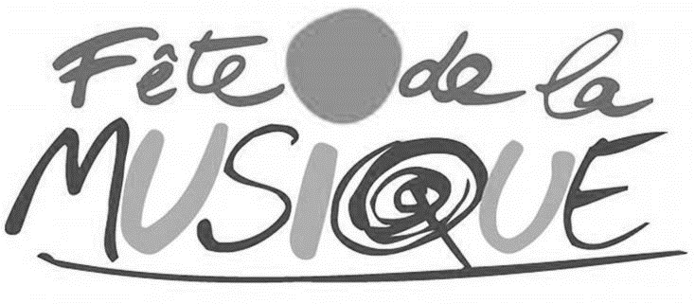

Artists Application Form
8 June 2019 - Fête de la musique - Newtown

Applications to be sent electronically by 26 April 2019
to fetedelamusiquejoburg@gmail.com

Name of the band/artist:

Genre:

Full name of all band members:

Contact
Name:
Tel:
Email:

Short biography (between 5 and 10 lines)

Links | Website:
 | Facebook:
 | Twitter:
 | Youtube links:
 | Soudcloud:
 | Spotify:
 | Other:

Material to be provided:
- Line up (group composition)
- Technical Rider
- Pictures (high resolution)
- Videos and music links and samples
- Press kit

